Create an Inter-Quake Model from MakeHuman

Pre-requisites
- MakeHuman (this document was written with the 1.2.0 version)
- Blender (this document was written with the 2.93.5 version)
- .mhx2 importer for Blender (http://www.makehumancommunity.org/content/plugins.html)

Create the model
- Open MakeHuman and create your model, using the Proxy741 in the Geometries -> Topologies menu
- Under Pose/Animate tab, select Skeleton, and in the Rig Presets group, select Game Engine
- In Files -> Export, select the MakeHuman Exchange(.mhx2) option above Mesh Format group, and save your file

Import in Blender
- If you still didn't it, install the .mhx2 importer. Open Edit -> Preferences... then select Add-Ons, and click Install... Select your downloaded package (the .zip file may be selected directly)
- Open a new scene and clear it completely
- Click on File -> Import... -> MakeHuman (.mhx2), and import your file
- Check if the model is well imported with its skeleton
- Select Layout view
- Select all your model meshes (press A key) and in Objects menu, select Join (or click Ctrl+J)
- Select Animation view (Ctrl+PgUp/Dn) and create your animation. To create a frame, select all your bones (press A key) and click right mouse button, then select Insert Keyframe... -> Whole Character

Export to IQM file
- Return to Layout view
- Select your model, and on the right panel, change the names (e.g. Name the animation, name the Skeleton « Skeleton » and name the model « Model »)
- Ensure that your model is well selected and select File -> Export... -> Inter-Quake Model (.iqm, .iqe)
- Configure the export options by taking care of indicate all the animations you want to export, separated by a commit (see screenshot below)
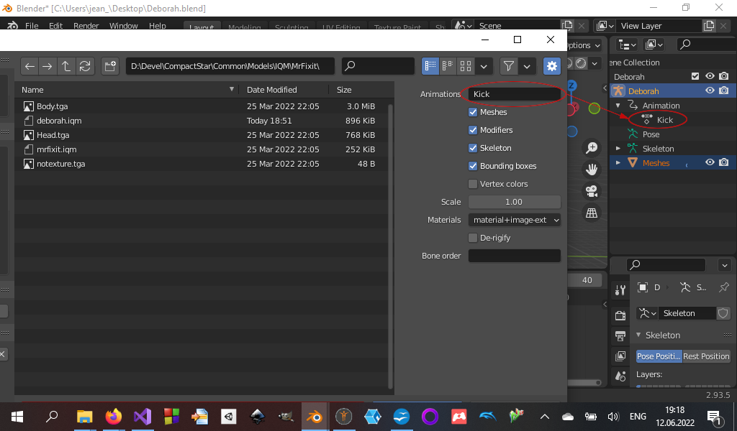
- Click on Export IQM

MORE SIMPLE
- Create with MakeHuman
- Export as binary FBX
- Import FBX model in Mixamo
- Animate with Mixamo
- Export from Mixamo as binary FBX + skin
- Import in Blender
- Adjust animation
- Export as IQM

